**Mini Project Report on**



**STOCK VALUE PREDICTION USING MACHINE LEARNING**  


**Submitted in partial fulfilment of the requirement for the award of the degree of**

**BACHELOR OF TECHNOLOGY**

**IN**

**COMPUTER SCIENCE & ENGINEERING**

**Submitted by:**

**Student Name-Aman Kaushik**  **University Roll No.- 2018662**

***Under the Mentorship of***

**Mentor Name- Dr. Sharon Christa**



**Department of Computer Science and Engineering**

**Graphic Era (Deemed to be University)**

**Dehradun, Uttarakhand**

**January 2023**



**CANDIDATE’S DECLARATION**

I hereby certify that the work which is being presented in the project report entitled **“STOCK VALUE PREDICTION”** in partial fulfilment of the requirements for the award of the Degree of Bachelor of Technology in Computer Science and Engineeringof the Graphic Era (Deemed to be University), Dehradun shall be carried out by the under the mentorship of **Dr. Sharon Christa, PGT**, Department of Computer Science and Engineering, Graphic Era (Deemed to be University), Dehradun.

Name-Aman Kaushik University Roll no-2018662 **signature**

**Table of Contents**

|  |  |  |
| --- | --- | --- |
| **Chapter No.** | **Description** | **Page No.** |
| Chapter 1 | Problem statement | 1 |
| Chapter 2 | Abstract | 2 |
| Chapter 3 | motivation | 3-4 |
| Chapter 4 | introduction | 5-7 |
| Chapter 5  Chapter 6  Chapter 7  Chapter 8 | System configuration  Methodology  Implementation and result  conclusion | 8  9-10  11-13  14 |
|  | References | 15 |

# **CHAPTER-1**

# **PROOBLEM STATEMENT :**

Time Series forecasting & modelling plays an important role in data analysis. Time series analysis is a specialized branch of statistics used extensively in fields such as Econometrics & Operation Research. Time Series is being widely used in analytics & data science. Stock prices are volatile in nature and price depends on various factors. The main aim of this project is to predict stock prices using Long short-term memory (LSTM).

**CHAPTER-2**

# **ABSTRACT :**

Stock market is very uncertain and highly volatile as the prices of stocks keep fluctuating due to several factors that make prediction of stocks a very difficult and complicated task. In the finance and trading world stock analysis and trading is a method for investors and traders to make buying and selling decisions. Investors and traders try to gain an edge in the markets by taking informed decisions by studying and evaluating past and current data. Stock market prediction has always been an important research topic in the financial and trading field. Prediction of stock market is the act of trying to determine the future value of a company stock (nifty & Sensex) or other financial instrument traded on an exchange. Our project explains the prediction of a stock using Machine Learning, which itself employs different models to make prediction easier and authentic. The paper focuses on the use of Recurrent Neural Networks (RNN) called Long Short Term Memory (LSTM) to predict stock values. This will help us provide more accurate results when compared to existing stock price prediction algorithms. The eminent analysis of the stock will be an asset for the stock market investors and will provide real-life solutions to the problems and yield significant profit.

**CHAPTER-3**

# **MOTIVATION** :

Efficient Market Hypothesis is one of the popular theories in financial economics. Prices of the securities reflect all the information that is already available, and it is impossible to outperform the market consistently. There are three variants of Efficient Market Hypothesis (EMH); namely weak form, semi- strong form, and the strong form. Weak form states that the securities reflect all the information that is publicly available in the past. Semi Strong form states that the price reflects all the publicly available data and also, they change instantly to reflect the newly available information. The strong form would include even the insider or private information.

But this theory is often disputed and highly controversial. The best example would be investors such as Warren Buffet, who have earned huge profits over long period of time by consistently outperforming the market. Even though predicting the trend of the stock price by manually interpreting the chaotic market data is a tedious task, with the advent of artificial intelligence, big data and increased computational capabilities, automated methods of forecasting the stock prices are becoming feasible. Machine learning models are capable of learning a function by looking at the data without explicitly being programmed. But unfortunately, the time series of a stock is not a function that can be easily mapped. It can be best described more as a random walk, which makes the feature engineering and prediction much harder. With Deep Learning, a branch of machine learning, one can start training using the raw data and the features will be automatically created when neural network learns. Deep Learning techniques are among those popular methods that have been employed, to identify the stock trend from large amounts of data but until now

there is no such algorithm or model which could consistently predict the price of future stock value correctly. Lot of research is going on both in academia and industry on this challenging problem.

**CHAPTER-4**

# **INTRODUCTION:**

Stock markets can be defined as dynamic, unpredictable, non-linear, and highly volatile in nature. Stock price predictions are very important among many business people and retail investors. Predicting stock market prices is a difficult and challenging task as they are complex and diverse and it depends on various economic factors like economic uncertainty, company’s financial reports and performance and price indicator as well as non-economic factors such as political conditions, and investor’s expectations, etc. The prices of stocks are mainly governed by demand and supply, and the ultimate goal of buying shares is to make money by buying stocks in companies whose share price is expected to jump up . Therefore, to obtain higher trading profits and reduce unnecessary losses, the investors usually expect various techniques to predict and analyse the stock price movements and various trends. Stock market prediction therefore has been a major research topic among researchers in the financial area and captivates the attention of many investors. Interpreting the stock price pattern of a particular company by considering their past data and predicting their future growth and financial development will be highly beneficial.

There are two common methods of attempting to forecast stock prices of an organization. The first is fundamental analysis, which considers external factors

like company profile, market situation, political and economic factors, textual information in the form of financial news articles, social media and even blogs by economic investigators. The second is technical analysis, that attempts to find patterns in charts and use past price trends of stocks like closing and opening price, volume traded, adjacent close values and many more, to predict future price action. Nowadays, for predicting stock prices, advanced intelligent techniques based on either technical or fundamental analysis are used.

Based on the data of historical stocks the stock price can be predicted. The most promising and prominent technique involves the use of Recurrent Neural Networks (RNN), that is basically the implementation of machine learning. Machine learning has been widely used in the capital market and plays a major role in predicting future stock prices based on historical data. Machine learning involves artificial intelligence which empowers the system to learn and improve from past experiences without being programmed time and again, thereby increasing the accuracy .

The proposed approach considers the available historic data of a particular share, and it provides predictions on a particular feature. In order to predict a share price for a required time period, the proposed model uses the time series analysis. This model applies a type of recurrent neural network (RNN) capable of addressing linear problems and predicting time series- Long Short Term Memory (LSTM) networks. LSTM is a deep learning technique. Long-term Memory (LSTM) units execute very long sequences. LSTM evaluates the time series data by using both the historical and the present stock data accurately. LSTM replaces the traditional artificial neurons in the network layer into the most useful memory cells. With these memory cells, networks are able to

associate memory with remote input over time. Over the past few years, LSTM has been applied to stock market prediction in different stock markets around the world.

The most important aspect of machine learning is the dataset used. The dataset should be as solid and concrete as possible because a little change in the data can prolong massive changes in the results. This dataset comprises the following closing variables for companies like TATAGLOBAL, Facebook, Tesla, Microsoft, and Apple. The model is then tested with the help of test data.

**CHAPTER-5**

# **SYSTEM CONFIGURATION:**

This project can run on commodity hardware. We ran entire project on an Intel I5 processor with 8 GB Ram, 2 GB Nvidia Graphic Processor, It also has 2 cores which runs at 1.7 GHz, 2.1 GHz respectively. First part of the is training phase which takes 10-15 mins of time, and the second part is testing part which only takes few seconds to make predictions and calculate accuracy.

## Hardware Requirements:

* RAM:- 8GB
* Storage:- 1TB
* CPU:- 2GHz or faster
* Architecture:- 32-bit or 64-bit

## System Requirements:

* Python 3.5 in Google Collab is used for data pre-processing, model training and prediction.
* Operating System: windows 7 and above or Linux based OS or MAC OS.

**CHAPTER-6**

# METHODOLOGY

## **6.1 - Recurrent Neural Network(RNN):**

A recurrent neural network (RNN) is a type of artificial neural network which uses chronological data or time series data. Recurrent neural networks utilize training data for knowledge. They are distinguished by their “memory” as they take information from previous inputs to influence the current input and output. On the other hand, traditional neural networks assume that inputs and outcomes are not related to each other, the output of the recurrent network depends on the prior attributes within the sequence. The main and most important feature of RNN is Hidden state, which can remember some data about a sequence.

## **6.2- Long-Short Term Memory(LSTM):**

The LSTM is a special kind of RNNs due to its ability to memorize sequences of data. It contains information in memory, similar to computer memory. This memory can be seen as a closed group of cells, with a closed description, the cell decides to store or remove information. Each node in LSTM consists of a set of cells which are responsible for storing data streams that have passed, in each individual cell there is the upper line which connects the models as a

transport line carrying the data from the past to the present ones, the independence of cells helps the model dispose of filters or add values of a cell to another. At last, the sigmoidal neural network (SNN) layer composing the gates drive the cell to an optimal value by disposing or letting data pass through.

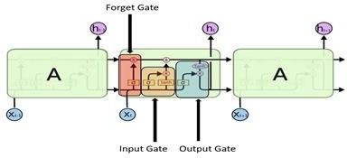

Figure-1 (LSTM Model)

There are three gates in LSTM: input, forget and exit gate. These gates determine whether new input should be allowed, data deleted because it is not important, or allow it to affect output at current timeline.

1. *Forget Gate:* It determines when certain parts of the cell will be inserted with data that is most recent. It subtracts 1 in parts of the cell state to be kept, and 0 in values to be ignored.
2. *Input Gate:* Based on the input, this network category reads the conditions under which information should be stored or updated in the state cell.
3. *Output Gate:* Depending on the input mode and the cell, this gate determines which information is forwarded in the next location in the network.

# **CHAPTER-7**

# IMPLEMENTATION AND RESULTS:

The implementation of proposed system using LSTM model using python shows the prediction of the future price of TATAGLOBAL share based on its historical data. The below visualization scatter plot figure shows the visualization of TATAGLOBAL prediction. In the result shown in the below graph is the plotted form our algorithm outcome by applying LSTM for achieving the accuracy.

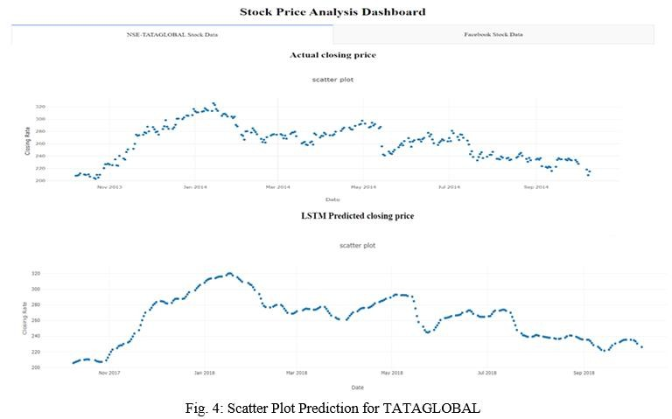

The above image shows a graphical representation of the closing price of a particular user selected stock. This scattered plot shows the date and time along with the closing price.

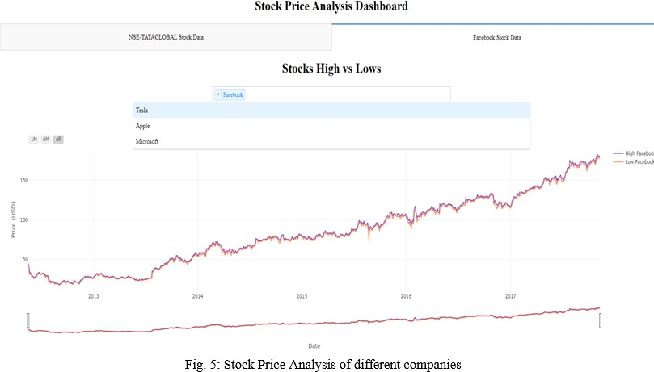

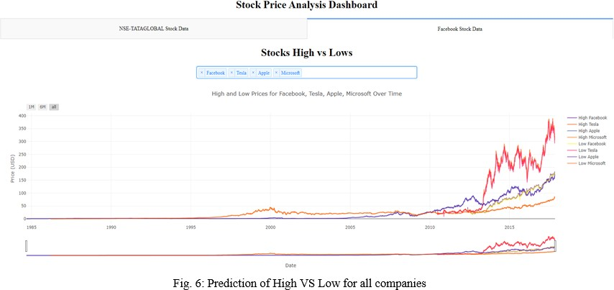This GUI consists of a drop down, which consists of stocks. The user is supposed to select single or multiple stocks from given stock list. It also shows a clear picture of highs and lows of selected stock.

This is stock analysis dashboard wherein the user can compare multiple stocks based on the past performance and he can decide whether they want to invest in these stocks or no.

The proposed model is able to predict the share price with very low loss and error rate. From the implementation and results, we can thus infer that in general, the prediction accuracy of the LSTM model improves with increase in the size of the dataset and makes is more efficient.

**CHAPTER-8**

# **CONCLUSION:-**

Predicting the stock market is a time-consuming and strenuous procedure. However, with the introduction to Machine Learning and its various algorithms, the Stock Market Prediction advancements have begun to include such approaches in analyzing stock market data. By measuring the accuracy of the different algorithms, we found that the most suitable algorithm for predicting the market price of a stock based on various data points from the historical data is the Long-Short Term Memory (LSTM) algorithm. The algorithm will be a great asset for brokers and investors for investing money in the stock market since it is trained on a huge collection of historical data and has been chosen after being tested on a sample data. The project demonstrates the machine learning model to predict the stock value with more accuracy as compared to other machine learning models. In the future, the stock market prediction system can be further improved by utilizing a much bigger dataset having higher computing capacities than the one being utilized currently and number of training epochs that better suit our assets and maximize our predictions accuracy. Furthermore, other models of Machine Learning could also be studied to check for the accuracy rate resulted by them. The sentiment analysis from social media can be linked with the LSTM to better train weights and further improve accuracy. It has led to the conclusion that it is possible to predict the stock market with more accuracy and efficiency using machine learning techniques.

# **REFERENCES:-**

[1] - Pritam Ahire, Hanikumar Lad, Smit Parekh, Saurabh Kabrawala, “LSTM Based Stock Prediction,” International Journal of Creative Research Thoughts(IJCRT), vol. 9, pp. 5118-5122, Feb. 2021.

[2] - Ya Gao, Rong Wang, and Enmin Zou, “Stock Prediction Based on Optimized LSTM and GRU Models,” Hindawi, vol. 2021, pp. 1-8, Sept. 2021.

[3] - Adil Moghar and Mhamed Hamiche, “Stock Market Prediction Using LSTM Recurrent Neural Network,” Sciencedirect, vol. 170, pp.1168-1173, Apr. 2020.

[4] - Mallikarjuna Shastry P. M. and Pramod B S, “Stock Price Prediction Using LSTM,” ResearchGate, vol. 83, pp. 5246-5251, May. 2020.

[5] - Ishita Parmar, Navanshu Agarwal, Sheirsh Saxena, Ridam Arora, Shikhin Gupta, Himanshu Dhiman, Lokesh Chouhan, “Stock Market Prediction Using Machine Learning,” in First Inter- national Conference on Secure Cyber Computing and Communications, 2018, doi: 10.1109/ICSCCC.2018.8703332

[6] - Uttamraj K R, Raghav Nandakumar, Vishal R, Y.V Lokeswari, “Stock Price Prediction Using Long Short Term Memory,” International Research Journal of Engineering and Technology (IRJET), vol. 05, pp. 3342-3348, Mar. 2018.